Add SSH Key to connect GitHub

<https://docs.github.com/en/authentication/connecting-to-github-with-ssh/generating-a-new-ssh-key-and-adding-it-to-the-ssh-agent>

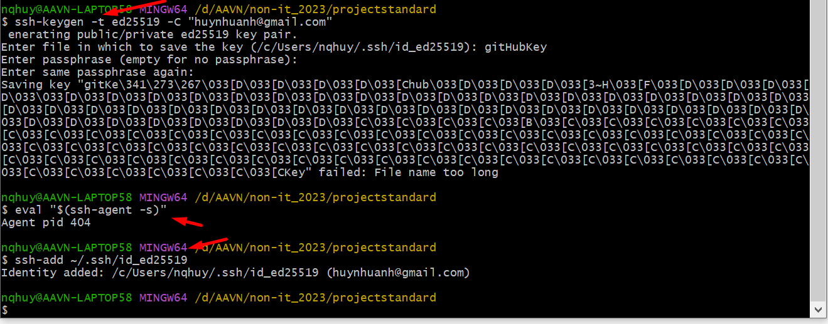

**Adding a new SSH key to your GitHub account**

<https://docs.github.com/en/authentication/connecting-to-github-with-ssh/adding-a-new-ssh-key-to-your-github-account>

Step1: Check if you have public key or not

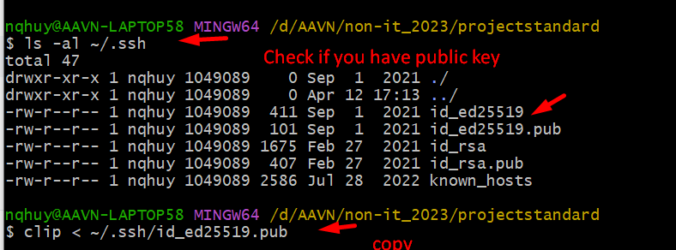

<https://docs.github.com/en/authentication/connecting-to-github-with-ssh/checking-for-existing-ssh-keys>

Step 2: Add public key on your GitHub account

